**HL Unit 5** – Abstraction Data Structures  
Quiz 1 - Trees

|  |  |  |  |
| --- | --- | --- | --- |
| **Question 1** | | | |
| Objectives: | 5.1.15, 5.1.16 | Exam Reference: | Nov-16 7 |

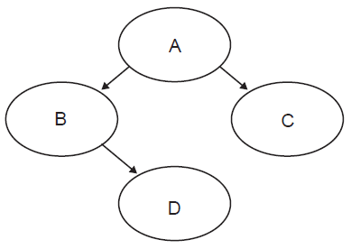Consider the following binary tree.

1. Identify all leaf nodes in this binary tree. [1]

D and C;

1. For this binary tree, state the result of:
2. inorder tree traversal, [1]

B D A C;

1. postorder tree traversal. [1]

D B C A;

|  |  |  |  |
| --- | --- | --- | --- |
| **Question 2** | | | |
| Objectives: | 5.1.15, 5.1.16, 5.1.17 | Exam Reference: | Nov-14 10 |

1. 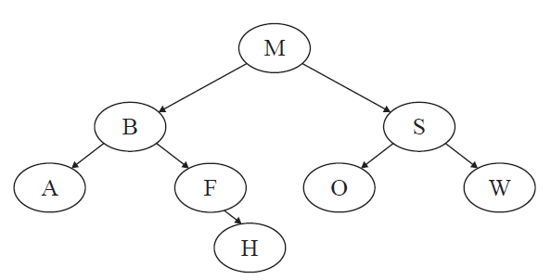Consider the following binary search tree.
2. State the order in which data will be listed using preorder traversal. [1]

*Award* ***[1 mark]*** *for correctly stating the solution.*

M B A F H S O W;

1. State the number of leaf nodes in the tree. [1]

*Award* ***[1 mark]*** *for stating the correct number of leaf nodes.*

4;

1. Construct the tree after adding the node L. [1]

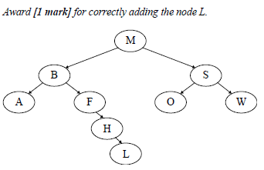

|  |  |  |  |
| --- | --- | --- | --- |
| **Question 3** | | | |
| Objectives: | 5.1.15, 5.1.17 | Exam Reference: | May-14 15 |

A suburban railway system for a large city in Southern Europe consists of two lines **L1** and **L2**,

which meet at the station Centro, where passengers can change from one line to the other.

The system is shown below.

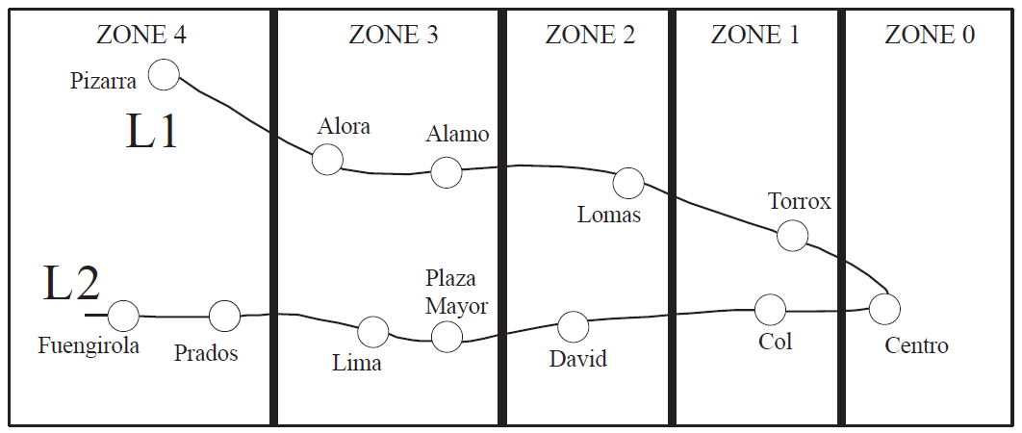

Each station is located in a particular zone, and the total number of zones in which the journey

takes place determines the train fare. Note, if a passenger starts in **Zone 1**, goes to **Zone 0** and

then back to **Zone 1**, the journey has taken place in **three** zones. Examples of the number of

zones are shown below for different journeys.

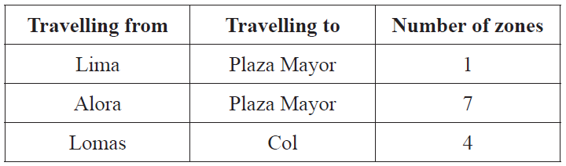

1. State the number of zones in which the journey takes place when travelling from Alora

to Fuengirola. [1]

8;

The data for each station (station name, line, zone) is stored on the system’s server in the

collection TRAIN_DATA. There are 12 stations in total. The first part of the collection is

shown below.

Centro, L1, 0, Alora, L1, 3, Torrox, L1, 1, Col, L2, 1, ...

From this we can see that Alora is part of line L1 and is located in Zone 3.

At the start of each day, the data in TRAIN_DATA is read in to the binary tree TREE, in which

each node will hold the data for one station. The binary tree will be used to search for a specific

station’s name.

1. Sketch the binary tree after the station data from the first part of the collection,

given above, has been added. [3]

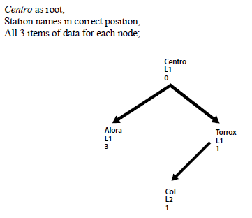

The TRAIN_DATA collection is also used to construct the one-dimensional array

STATIONS (which only contains the list of station names sorted into alphabetical order),

where STATIONS[0] = Alamo.

1. State the value of STATIONS[4]. [1]

David;

The two data structures (STATIONS and TREE) are now used to construct the two‑dimensional array FARES containing the fares between stations, partly shown below. Note that the fare for travelling in each zone is €1.00.

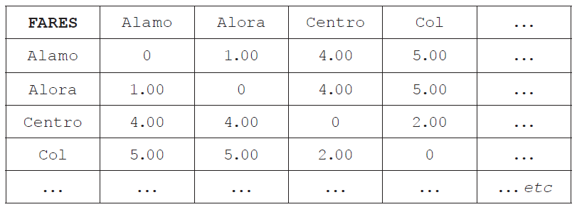

1. Calculate the fare for travelling from Torrox to Lima. [1]

5.00 (Euros);

*Accept 5.*